lab 5:

Example 1:

Input :

Example 2:

Input :

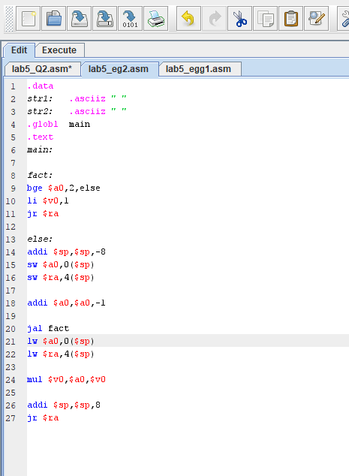

Example 3:

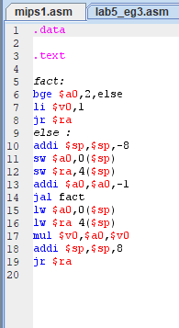

Exercise :

Question 1:

Upper case and lower case program print the message indicate whether ch is a lowercase character or not .

Input:

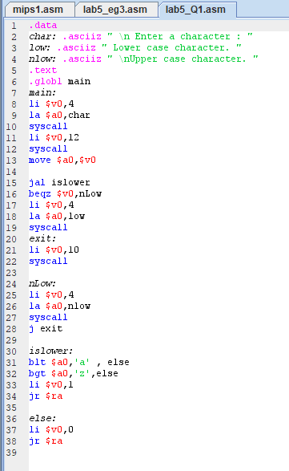

Output :

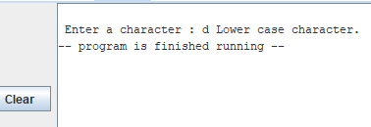

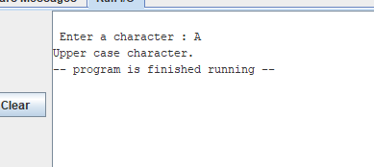

Question 2:

Function that reads the array of an integer . The function read must receive two arguments .

Input :

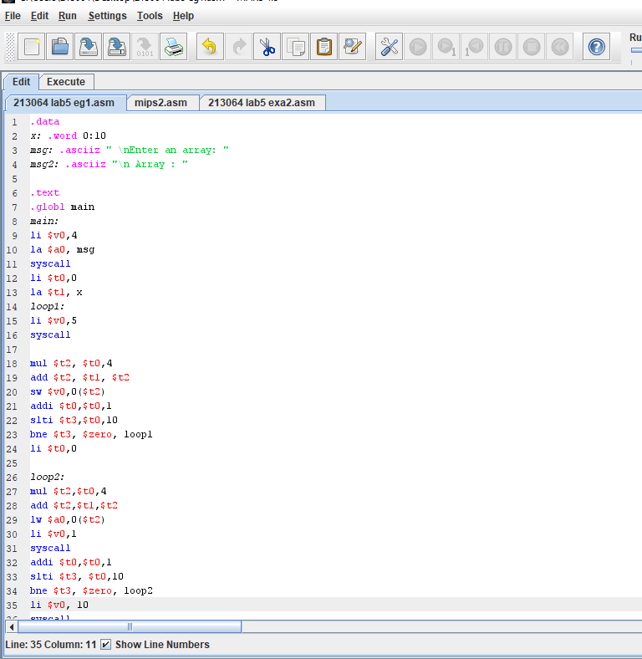

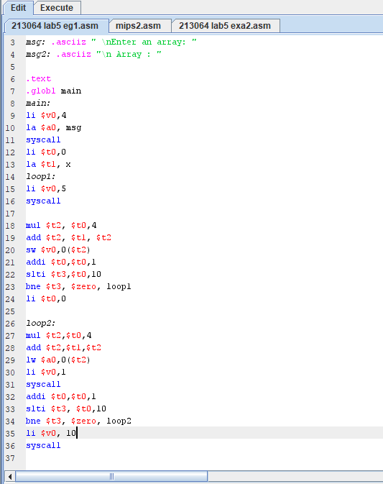

Output :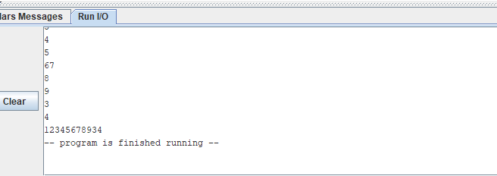

Question 3:

Question 4:

Function that receive two arguments of an array of integers :

Input:

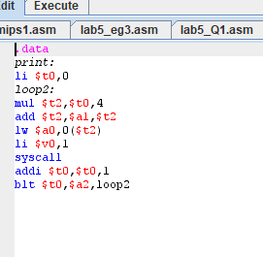

Output :

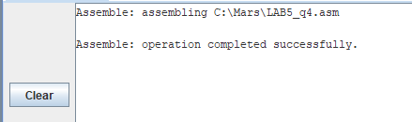

_______________________________________________________________________________________________________

LAB 6:

Examples :

Q _1:

Traversing the values :

Input :

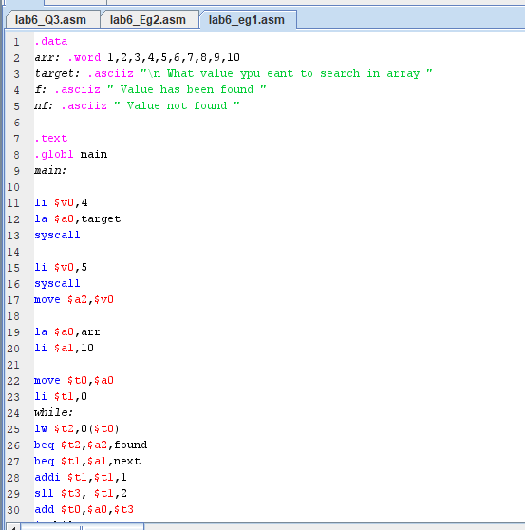

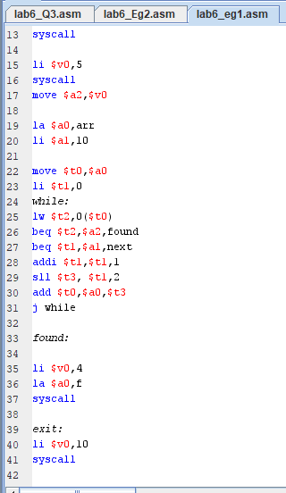

Output :

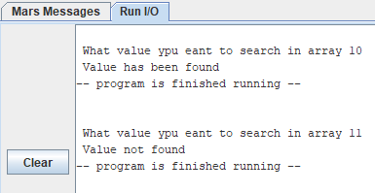

Q _2 :

2 DIMENTIONAL ARRAY

Input :

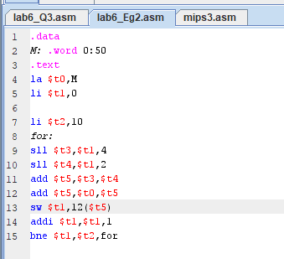

Output :

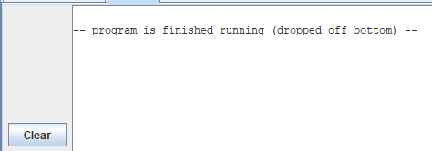

Q_3 :

Instruction in the loop :

Input :

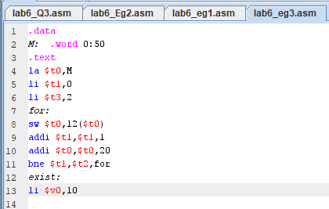

Q_4 :

Mips program that writes a string to an output file :

Input :

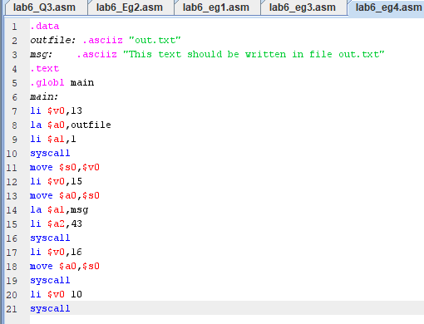

Output :

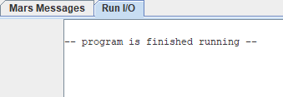

_______________________

Exercise Questions :

Question 1:

Given the following data definition statements, compute the addresses of arr2, arr3, str1, and str2, given that the address of arr1 is 0x10010000. Show your steps for a full mark. Select “Show Labels Window (symbol table)” from the Settings menu in MARS to check the values of your computed addresses.

Input :

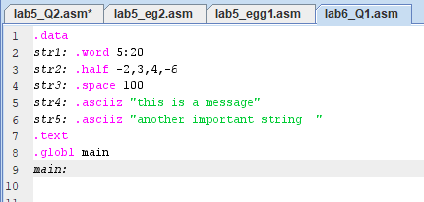

Output :

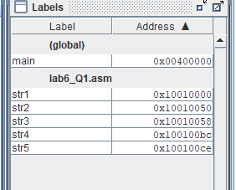

___________________________________

Question 2 :

In problem 1, given that arr1 is a one-dimensional array of integers, what are the addresses of arr1[5] and arr1[17].

Input :

____________________

Question 3: Write a MIPS program that defines a one-dimensional array of 10 integers in the static area of the data segment, asks the user to input all 10 array elements, computes, and displays their sum.

Input:

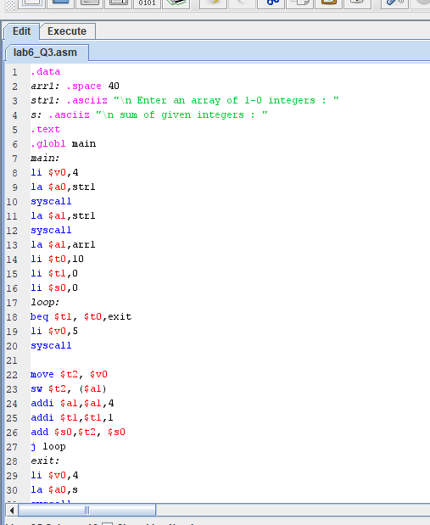

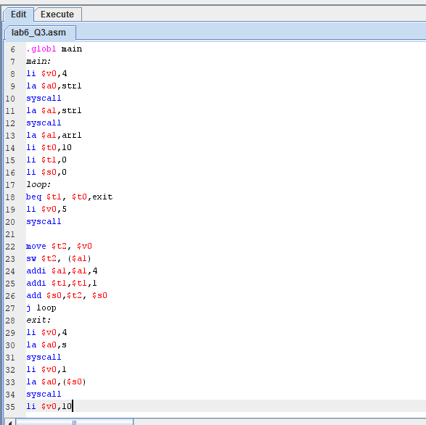

Output : 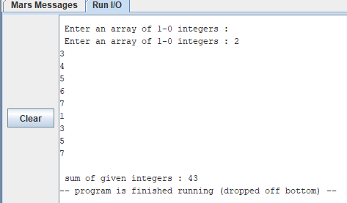

Question 4 :

Write a MIPS program to copy an input text file into an output file. The input and output file names should be entered by the user. If the input file cannot be opened, print an error message.

Input :

Output :

Lab 7 :

Examples :

Q1:

The following MIPS code converts the unsigned integer stored in register

into a string in the data segment in memory :

Input :

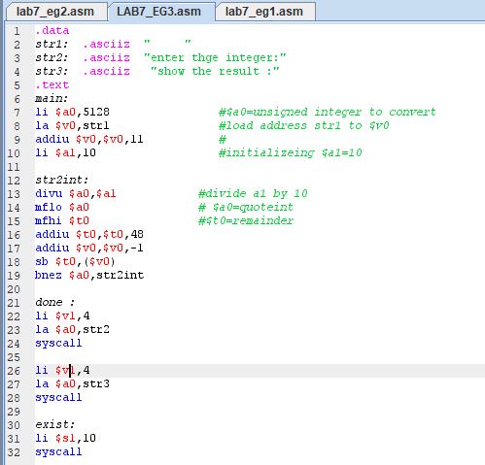

Q2:

The following MIPS loop converts the above string STR into an integer computed in register $v0 :

Input :

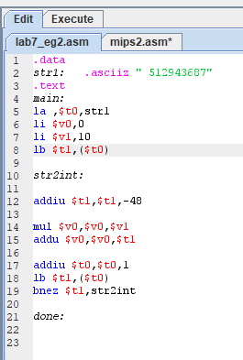

Output :

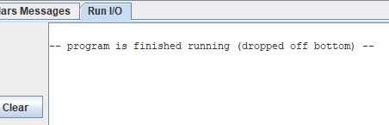

Q3:

Gcd example :

Input :

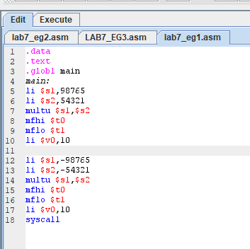

Output :

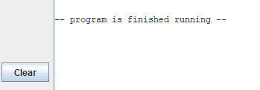

Exercise questions :

Lab 8 :

Exercise Qs:

Question no 3:

Trace the following program comment on the sums of array1 and array2 elements computed in registers $f4 and $f9 ,respectively. Now use the MARS tool to trace the execution of the program and verify your results. What conclution can be made from exercise ?

Input :



